How to Use the WNC Safety Data Layers
The safety data layers represented in the online map FBRMPO Safety Plan Maps were developed for the Safe Streets for WNC transportation safety action plan. The WNC safety plan region includes all areas of Buncombe, Haywood, Henderson, Madison and Transylvania counties. The following is an introductory description of each layer shown and terms used.

Layers Shown
Pro Tip: When first opening the online map, turn off most or all layers by clicking on the symbol.
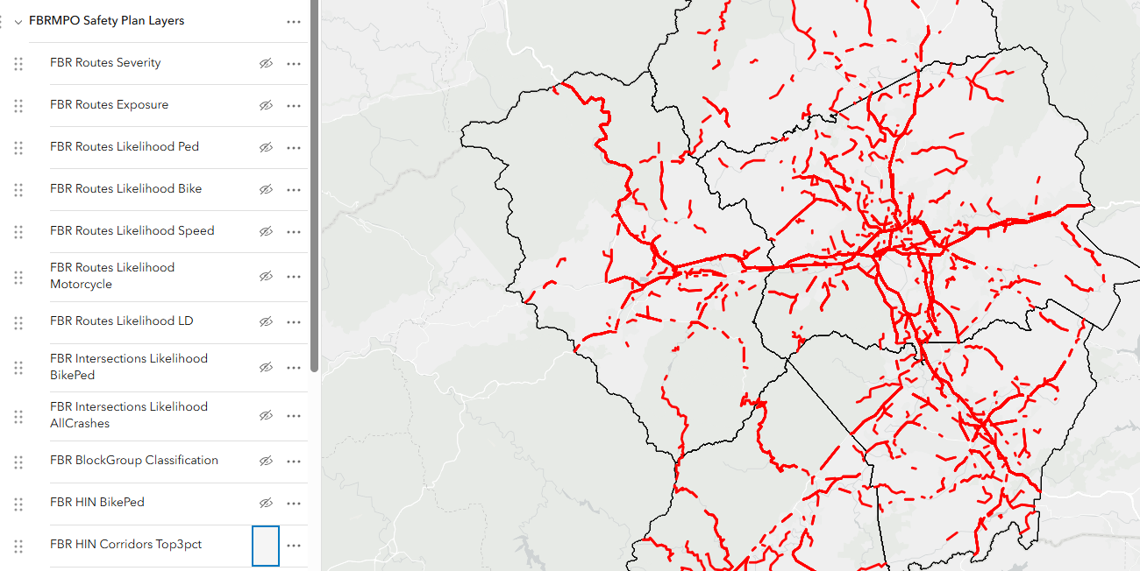

HIN Corridors Top 3pct: High Injury Network (All Crashes)
This layer shows the corridors including the top 3% of segments as rated based on frequency and severity of all crashes that occurred between 2016-2023 in the counties included in the WNC region.

Intersection TotalTop1pct: High Injury Intersections (All Crashes)
This layer shows the top 1% of intersections as rated based on frequency and severity of all crashes that occurred between 2016-2023 in the counties included in the WNC region.

HIN BikePed: High Injury Network for Bicyclists and Pedestrian Crashes
This layer shows the corridors including approximately the top 1% of segments as rated based on frequency and severity of bicycle or pedestrian-related crashes that occurred between 2014-2023 in the counties included in the WNC region.

VRUTop1pct: High Injury Intersections for Bicycle and Pedestrian Crashes
This layer shows the top 1% of intersections as rated based on frequency and severity of bicycle or pedestrian-related crashes that occurred at intersections between 2014-2023 in the counties included in the WNC region.

[County] HIN Segments: High Injury Network per County (All Crashes)
This layer shows the results of raw analysis of the top 3% of segments as rated based on frequency and severity of all crashes that occurred between 2016-2023 in the counties included in the WNC region. This will typically show a more fragmented set of locations that the HIN Corridors Top 3pct layer.

Routes Likelihood
These layers comprise segments or intersections with very low to very high probability or risk for a serious injury or fatal crash involving or related to one of the following crash types:
- Routes Likelihood LD: Risk for Lane Departure Crashes
- Routes Likelihood Bike: Risk for Bicycle Crashes
- Routes Likelihood Ped: Risk for Pedestrian Crashes
- Intersections Likelihood BikePed: Risk for Bicycle and Pedestrian Crashes at Intersections
- Intersections Likelihood All Crashes: Risk for Intersection Crashes
- Routes Likelihood Motorcycle: Risk for Motorcycle Crashes
- Routes Likelihood Speed: Risk for Speed-Related Crashes

ProTip: To reduce visual clutter in the risk layers, adjust the settings of each risk layer by changing the visual properties to turn off Very Low and Low Risk classifications. This will remove most green lines from the map.

Block Group Classification: Context Typologies at the block group level.
This layer shows the area block groups as classified per one of the five context classifications developed for the safety plan.

Route Exposure
This layer shows degrees of exposure, classified by ranges of traffic volume (AADT), for all roadway segments. The higher ranges of AADT typically result increased frequency of crashes of all severities.

Route Severity
The layer shows the observed speed (measured by the 85th percentile speed recorded for a segment for a 24-hour weekday average) using remote or probe data. This information is most reliable on high volume roads and is less reliable on secondary or local streets.

Percent Change in Crashes
The following layers describe the expected future increase or change in crashes of varying severity. “KABCO” refers to the crash injury severity scale. This information is most useful for prioritizing areas where future investment should be focused. Layers showing Percent Change in Total K (fatal) and A (serious injury) Crashes are key layers for use.
- Percent Change in Total KABCO Crashes
- Percent Change in Total KABC Crashes
- Percent Change in Total KA Crashes
- Percent Change in Total K Crashes
- Percent Change in Total KABCO Crashes
- Percent Change in Total K Crashes

Terminology and Definitions
Bicycle Risk – A multivariate measure of crash type risk associated with various roadway characteristics and local context. Higher levels of bicycle risk correlate to higher travel volumes, higher number of lanes, and on roads classified as a US Route, NC Route, or Secondary Route. Additionally, bicycle risk has a positive correlation with an urban land use context and is positively associated in areas that have higher concentrations of population and employment density, have a school or university nearby, and is within an area with a higher Social Vulnerability Index Score.

Bicycle and Pedestrian Intersection Risk - A multivariate measure of crash type risk associated with various roadway characteristics and local context. Higher levels of intersection risk are associated with higher intersection AADT, 4 or more legs within the intersection, and presence of traffic signals and transit stops. Additional factors include a positive association where the intersection is located in an urban context or is within an area with a high Social Vulnerability Index Score and population and employment density. The prevalence of zero-vehicle households was not significant in the risk of bicycle and pedestrian crashes at intersections.

Block Group (Context) Classification – The five classifications include: Rural Town, Rural, Suburban, Urban, and Urban Core, developed utilizing the NCHRP Research Booklet 1022: Context Classification Application: A Guide. The classifications were identified based on characteristics such as municipal location, intersection density, and building area density.

Exposure – A measure of road usage patterns through annual average daily traffic (AADT). This measure helps to identify areas where higher traffic volumes may increase the frequency of crashes.

Future KA (Bike/Ped KA) Crash Rate – A predictive model for the expected number of crashes to increase or decrease between the base year of 2015 through future year 2045. The models for the FBRMPO results are not calibrated to local conditions; models are pulled directly from the NCHRP 1044 research. Results from this analysis should be used to either compare one Traffic Analysis Zone (TAZ) to another or to understand the percent change in crashes for a TAZ between 2015 and 2045.

High Injury Network (HIN) – The High Injury Network (HIN) is a collection of roadways that have a disproportionately high number of fatal and serious injury crashes compared to the entire roadway network. The High Injury Network is comprised of four deliverables:
- High Injury Network – All crashes, regardless of crash type
- High Injury Intersections – All crashes, regardless of crash type
- High Injury Network – Bicycle and pedestrian crashes only
- High Injury Intersections – Bicycle and pedestrian crashes only

Intersection Risk - A multivariate measure of crash type risk associated with various roadway characteristics and local context. Higher levels of intersection risk are associated with higher intersection AADT, 4 or more legs within the intersection, presence of traffic signals and transit stops, and where the geometry of the intersection is at less than a 70-degree angle. Additional factors include a positive association where the intersection is located in a rural, suburban, or urban core, or is within an area with a high Social Vulnerability Index Score but is negatively associated with population and employment density.

Lane Departure Risk – A multivariate measure of crash type risk associated with various roadway characteristics and local context. Higher levels of lane departure risk correlate to higher travel volumes, fewer number of lanes, and on roads classified as a US Route, NC Route, or Secondary Route. Additionally, lane departure risk is positively associated with the roadway in a rural, suburban, or urban area, have higher concentrations of population and employment density, not have a school or university nearby, and is within an area with a higher Social Vulnerability Index Score.

Motorcycle Risk - A multivariate measure of crash type risk associated with various roadway characteristics and local context. Higher levels of motorcycle risk correlate to higher travel volumes, higher number of lanes, and on roads classified as a US Route, NC Route, or Secondary Route. Additionally, motorcycle risk has no correlation with land use context but is positively associated in areas that have higher concentrations of population and employment density, have a school or university nearby, and is within an area with a higher Social Vulnerability Index Score.

Pedestrian Risk - A multivariate measure of crash type risk associated with various roadway characteristics and local context. Higher levels of pedestrian risk correlate to higher travel volumes, higher number of lanes, and on roads classified as a US Route, NC Route, or Secondary Route. Additionally, pedestrian risk has no correlation with land use context but is positively associated in areas that have higher concentrations of population and employment density, have a school or university nearby, and is within an area with a higher Social Vulnerability Index Score.

Severity – A measure of observed roadway travel speed at the 85th percentile during workdays for a 24-hour period. This data is derived from a 2023 snapshot of the Regional Integrated Transportation Information System (RITIS) – a proprietary source that has aggregated probe and connected vehicle data to a network. This measure helps identify roadway corridors where targeted interventions to manage speed could reduce the potential for fatal and serious injury crashes.

Speed Risk – A multivariate measure of crash type risk associated with various roadway characteristics and local context. Higher levels of risk for speed-related crashes correlate to higher travel volumes, fewer number of lanes, and on roads classified as a US Route, NC Route, or Secondary Route. Additionally, speed-related crash risk is positively associated with the roadway in a rural or suburban, have higher concentrations of population and employment density, not have a school or university nearby, and is within an area with a higher Social Vulnerability Index Score.

